ENGAGEMENT, PARTICIPATION AND COMMUNICATION
SUB GROUP

TERMS OF REFERENCE

- INTRODUCTION

This document has been produced in line with the requirements of Part 7 of the Social Services and Wellbeing Act 2014.

The Cwm Taf Morgannwg Safeguarding Board (CTMSB) is a statutory body and covers the local authority areas of Rhondda Cynon Taf, Merthyr Tydfil County Borough Council and Bridgend, with RCT being the Lead Partner for the Board.

AIM OF THE ENGAGEMENT, PARTICIPATION AND COMMUNICATION SUB GROUP

The Engagement, Participation and Communication Sub Group (EPC) will on behalf of the CTMSB, ensure that the Board communicates effectively and appropriately with its stakeholders by bringing together representatives from partner organisations who will ensure that opportunities for engagement, communication and participation with staff, service users and the public are maximised.

The EPC will also ensure that there are effective mechanisms in place for the strategic co-ordination of public engagement activity, consulting, involving and co-producing with children, young people and adults at risk, and their carers and professionals on matters relating to safeguarding.

OBJECTIVES

The Engagement, Participation and Communication Group will have responsibility for ensuring that the following functions of the CTMSB, aligned to the Social Services and Wellbeing Act 2014, are carried out effectively:

- to raise awareness to the public and practitioners of the Board’s objectives to protect and prevent children, young people and adults from becoming at risk of abuse, neglect and other forms of harm, and to provide information about how this might be achieved.
- specify when and how children, young people or adults who are, or may be, affected by the exercise of a Safeguarding Board’s functions must be given the opportunity, to participate in the work of the Board.
- disseminate information about best practice and learning arising from MAPF’s CPR/APR reviews and audits, to relevant stakeholders. This will include children, young people and adults who are or may be affected by the exercise of a Safeguarding Board’s functions.

Raising awareness of abuse, neglect and harm in the Board’s area

The EPC group should ensure that partner agencies contribute to raising the profile of Safeguarding across Cwm Taf Morgannwg and the work of the Safeguarding Board. It should also be active in developing knowledge and understanding of its objectives and of the nature and scope of abuse, neglect and other kinds of harm in its area. This must be achieved through publicising its own work through the Annual Report and Annual Plan, by engagement and collaboration with other professional and community agencies, utilising strong coordination with service users and members of the public.

These are important steps in fostering relationships and building confidence in services involved in safeguarding, whilst raising awareness throughout the area of the need to protect and prevent abuse and harm to children, young people and adults who may have care and support needs.

Participation and Engagement

Section 135(4) (C) of the Act indicates that Regulations must specify when and how children, young people or adults who are, or may be, affected by the exercise of a Safeguarding Boards functions must be given the opportunity, at least once a year, to participate in the work of the Boards. As such, the annual EPC work plan will set out how this will be achieved

The EPC group should consider opportunities for user engagement in all aspects of its work. The effectiveness and impact in terms of outcomes of service user participation will also be evaluated and included in the CTMSB Annual Report.

Safeguarding Boards must work within the ethos of Voice and Control which underpins the Act to support people to achieve their wellbeing outcomes. The work of the CTMSB will be better informed through engaging directly with those affected, which will in turn assist the Board in its forward planning and performance evaluation.

Opportunities to participate in the Safeguarding Board’s work should be identified, maximised and recorded by the EPC group and should be achieved wherever possible through existing structures, campaigns and activities.

Safeguarding Boards must ensure participation is as inclusive as possible given the various care and support needs of children, young people and adults.

Communication and Participation Strategy

A Communication and Participation Strategy has been developed for the EPC group to use as a framework to provide information to the public, service users, professionals and others interested in the welfare of children, young people and adults at risk and to effectively engage with communities within the region and to involve them in the work of the Board.

The Communication and Participation Strategy can be accessed below:

Ladder of Participation

A Ladder of Participation (please see below) has been developed by the Board in order to measure how well we are doing in engaging with our communities and service users.

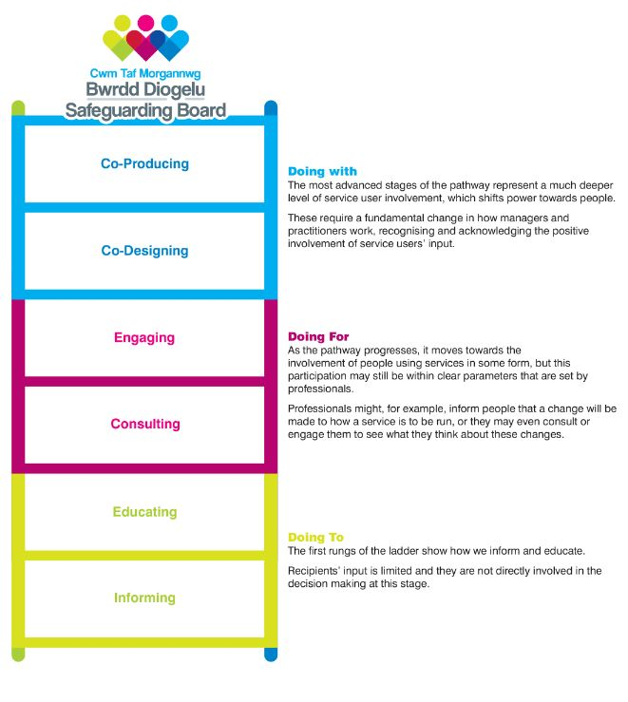
Guidance on how the Ladder of Participation is to be used, can be accessed here:

Disseminating information about best practice and learning

As part of developing a positive culture of learning and development, the EPC group will ensure that the Board’s work is communicated within the workforce to inform them about best practice and learning arising from reviews, audits and other Board activities.

ACCOUNTABLITY

Members will be ultimately accountable to the CTMSB and to their own agencies for the work carried out by the EPC Sub Group.
Members will be responsible for reporting to their own agencies to disseminate learning and update staff on the work of the EPC group and the Board generally.

The Sub Group will develop, implement and monitor a work plan, which will contribute to the wider objectives of the CTMSB and its annual plan. Additional work arising throughout the year will be considered and reported to the CTMSB as appropriate.

A report card will be completed for the Joint Operational Committee meetings by the Chair on a quarterly basis.

MEMBERSHIP

The Engagement, Participation and Communication Sub Group will include people from relevant agencies across Cwm Taf Morgannwg with organisational responsibility for those who will partake in engagement, participation and communication activities. These staff should have sufficient authority to make decisions in relation to engagement, participation and communication, or be able to respond to the requirements/requests of the sub group in a timely manner.

It should also include members with sufficient knowledge of engagement and participation processes to enable them to make informed decisions regarding the development and evaluation of the Communication and Participation Strategy.

Additional persons will be co-opted as required for specific pieces of work.

Members will be expected to participate in at least 75% of meetings. This will be monitored by the Chair and reported to the Joint Operational Committee.

Fully briefed deputies can be used as a substitute where they meet membership requirements.

A list of members is as follows:

NAME | TITLE | ORGANISATION
Lyndon Lewis | Head of Service,  (Chair) | Cwm Taf Morgannwg YOS
Jackie Neale | Adult Safeguarding Service Manager,  (Vice Chair) | RCTCBC
Daniel Williams | Head of Service Access and Inclusion | RCTCBC
Adele Stacey | Education and Welfare | MTCBC
Gail Biggs | Head of Service Access and Inclusion | BCBC
Carol Smith | Safeguarding Coordinator Adults | MTCBC
Alyson Williams | Safeguarding Coordinator Adults | RCTCBC
XX | Safeguarding Coordinator Adults | BCBC
Paul Lewis | Public Protection | MTCBC
Judith Jones | Partnerships & Community Safety Manager | BCBC
Gary Black | Partnerships & Community Safety Manager | RCTCBC
Debbie Evans | VAWDASV Regional Advisor for Cwm Taf Morgannwg
XX | XX | NPS
Dan Michel | XX | South Wales Police
xx | xx | Barod
Nikki Kingham | Business Manager | CTMSB
Claire O’Keefe | Head of Safeguarding & Public Protection | CTMUHB
Beth Melhuish | Communication and Engagement Officer | CTMSB
Isobel Jones | Head of Patient Experience & Community Involvement, | WAST
Catherine Tyler | Participation Officer | RCTCBC
Jan Watkins | Participation Officer | Merthyr Youth Forum
Kelly Cobb | RCT Youth Engagement and Participation Service Team Leader | RCTCBC
Lois Sutton | Children’s Rights and Participation Worker | BCBC
xx | XX | BAVO
Stacey Williams | Young People’s Participation Officer | Interlink
Claire Williams | Health and Well-Being Manager | VAMT
Karen James | xx | Coleg Y Cymoedd
Sam Gunnarsson | Safeguarding and Well-being Manager | Bridgend College
Sara Fowler | xx | Merthyr College
Iwan Dowie | Head of Post Registration (Professional Regulation) | University of South Wales
Liam Ronan | Communications and Engagement | BCBC
James Whitehurst | Communications and Engagement | RCTCBC
Vicky Robst | Communications and Engagement | MTCBC

In addition to the membership list above, the EPC Group will also have co-opted members who will be required to attend meetings when there are items on the agenda relating to their area of work.

CTMSB’s Communications and Engagement Officer will liaise with the Communication Officers from partner agencies when there is information to disseminate via their channels in order to raise awareness of issues.

Chairing Arrangements

The Chair will be a member of the CTMSB and the appointment will be agreed by the Sub Group and the Board.

A Vice-Chair from one of the CTMSB partner agencies will be appointed by the Sub Group and agreed by the Board.

These posts will be reviewed every 2 years.

FREQUENCY OF MEETINGS

The Engagement, Participation and Communication Group will meet at least four times per annum.

The agenda for each meeting will be determined by the Chair, working in conjunction with the CTMSB Communication and Engagement Officer, based on the Sub Group work plan, emerging themes/issues and from the agreed actions of previous meetings. The CTMSB will direct the work of the Group.

Task and Finish Groups will be set up and will involve relevant representatives from partner agencies as required.

