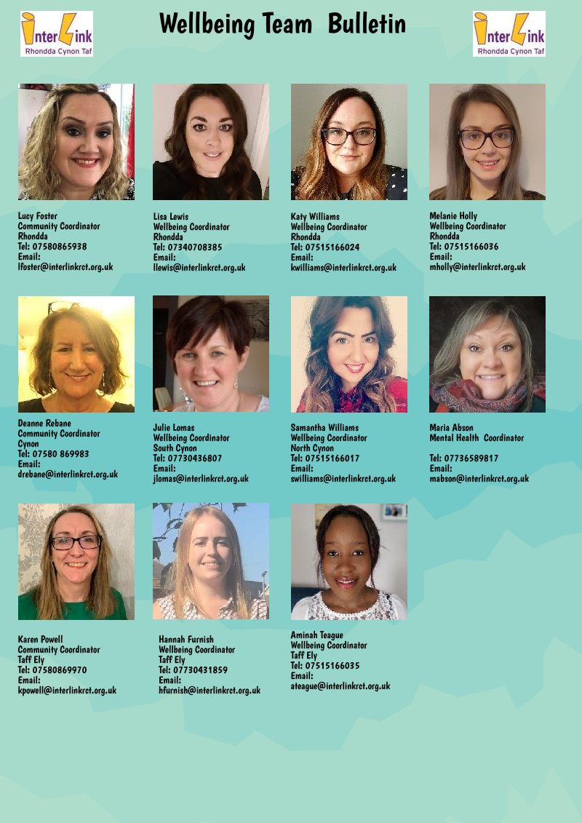

All information contained in this bulletin is correct at time of publishing.
Rhondda Valleys
Find us on Facebook as “Rhondda Wellbeing Coordinators” for all the latest help, support and advice: Click here

Rhondda Food Bank: Please take your vouchers if you have one. If you don’t and you are in crisis please contact: Wellbeing@interlinkrct.org.uk

The Play Yard: Providing Food Hampers every Wednesday on a first come first serve basis for £5. Also supplying free lunches for children of all ages. Collection is preferred but delivery is available for those most in need. There is an online form on their Facebook page, or you can contact them on: Call 01443 303300.
Click here

The Lion Hotel: The Lion Lockdown Menu. Delivering every Monday, Wednesday, Friday, Saturday and Sunday in the Upper Rhondda. Meals include Sunday dinner, pasta, salads, rolls, and pub classics. All bookings must be ordered by 5pm the day before. To book your delivery send a Private Message or text: 07950420549 Click here

Cwm Farm Shop Treorchy: Free grocery delivery service and homemade meals at reasonable prices.
Contact them on: 01443 778106 Click Here

Fun Fillings: Offering Hot and Cold foods in the CF39 Area (Ystrad to Coed Ely. Porth to Wattstown)
Contact them on: 01443 422557 Click Here

The Best Café: Delivering Afternoon Tea for two £15. Based in Pentre. Click here

Treorchy Florist: Offering a collection and delivery service of Fruit and Veg packs. They will deliver from Blaencwm to Llwynypia and Maerdy to Pontygwaith. Contact them on: 01443 777755 Click Here

The Bistro Group: Treorchy - Delivering from Blaencwm to Ystrad. Delivering hot and cold food including Breakfasts, burger, chips and treats. The full menu can be found on their website www.thebistrogroup.co.uk.
Contact them on: 07394 738964 Click Here

WR Bishop - Home deliveries or collection throughout Rhondda - £10/£20/£30 fruit and veg boxes/ £10 everyday essentials boxes. Contact 01443 670355.

Rhondda Fach
The four shops listed below are working together to coordinate deliveries of each other’s services:

Ken’s Butchers Ferndale: Selling meat selection. Will deliver from Maerdy to Pontygwaith.
Contact 01443 730581 Click Here
Dylan’s Pet Shop Ferndale: Will deliver from Maerdy to Pontygwaith.
Contact 01443 757575
Nash’s Shop Ferndale: Delivering Fruit and Veg. Will deliver from Maerdy to Pontygwaith.
Contact 01443 756646
The Bakehouse Ynyshir: Delivering fresh breads, cakes, pasties, pies etc. Will deliver from Maerdy to Pontygwaith. Contact Anetta 07875966036

Cynon Valley
Find us on Facebook as ‘Cynon Wellbeing Coordinators’ where we post up to date information, support and advice from around the Cynon Valley: Click here
Aberdare Covid19 Community Support Group: Helping people stay connected in the local community. Access them through Facebook: Click here
The Marquis Inn Aberdare: Selling the following: 30 Eggs = £4.50 Flour; Plain/Self raising= £1 per Kilo. Free Delivery on Orders over £7. Call 01685 875822 to make your order.
Cynon Valley Organic Adventures: Supporting people in the community with: Picking up shopping or supplies, Posting mail, A friendly phone call, Prescriptions, supporting actions e.g. dog walking
Understanding Health Guidance, Advice on employment rights and financial concerns e.g. self-employment available on: Click here
Church Village Caterers- Delivering Sunday Roast; 2 course Dinners with a Choice of Meats and Desserts. Order by 6pm on Saturday ready for Sunday. Covering Abercynon down to Church Village Mountain Ash, Aberdare and Merthyr. Contact: 07525658728 to place your order.
Dave’s Family Butchers-Aberdare: New Opening Times: Tuesday, Wednesday, Friday Saturday 8am-2.30pm Thursday 8am-.1pm. Not taking orders over the telephone, following government guidelines and running business as usual through the shop.
Creature Comforts- Aberdare: Usually in the market. Delivering pet supplies every day, free delivery. Contact: 07947591120 or visit: Click here
Veg Box- Aberdare: Usually in the market. Delivery Service- Please contact 07460049535 to place an order on fruit and vegetables.
Farmers Fresh Fruit Company: Delivering fresh fruit from Rhigos- Aberdare town. Place orders on Facebook: Click here or contact: 01639 720696

Taff Ely
Find us on Facebook as “Taff Ely Wellbeing Coordinators” for all the latest help, support and advice:
Click here

Ynysybwl Vision – offering a telephone befriending service which began on the 6th April. If you feel like a chat then please ring 07498 309308, Monday – Friday, 10am – 12 midday.
Llanharan Drop-in – Has now closed childcare provision. Local support still available through:
Llanharan Community Resilience Volunteers – Support for those needing help with shopping or small errands due to self-isolating. Please contact Catherine Kennedy on 01443 231430 or 07745642136 or email actingclerk@Llanharancc.co.uk. Covering Llanharan and the surrounding area, including Pencoed and Pontyclun if needed. If you are willing and able to volunteer to carry out tasks for vulnerable people in this community, please also contact on the same details.
Miskin Community Friends – covering Miskin (Pontyclun) and estate of Cefn yr Hendy. Providing volunteer support to residents self-isolating or unable to leave the house with shopping, friendly phone calls and other urgent supplies. Please contact Andrea Hitchcock on 07449 145848 or hitchcock.andrea@gmail.com
Boar’s Head, Pontyclun - converted into a local shop stocking all essential products, including dried goods such as flour, sugar, pasta, rice and detergent along with fresh produce such as bread, fresh milk, meat and vegetables. Offers a local delivery service to those within the Pontyclun area who are vulnerable, over 70 or self-isolating. Takeaway Sunday lunches also available and for the elderly in the community, the team will deliver a Sunday lunch free of charge to their home. Call 01443 22400 for more details.
Taff Ely Foodbank - Providing emergency support to those in crisis. Open at Bethel Baptist Church, Pontyclun. Monday - Friday, 9am-1pm. Offering deliveries of emergency food parcels to people self-isolating. Still accepting food donations (non-perishable) at local supermarkets and Bethel Baptist Church during opening hours. Contact Andrew Butcher on 07900 557379.
Pontypridd Foodbank - Providing emergency support to those in crisis. Open at St Luke's Church, Rhydyfelin, Monday & Friday 2-4pm and Wednesday 10am-12noon. Offering deliveries of emergency food parcels to people self-isolating. Please contact your housing officer, Citizens Advice or a member of your local wellbeing team (contacts on page 1) if you need a voucher. Still accepting food donations (non-perishable) at Sainsbury’s Ponytpridd and St Luke’s Church, Rhydyfelin during opening hours. Contact Mandy Haydon-Hall on 07562137392.
Pontyclun Community Friends: Providing community support through volunteers to those self-isolating in Pontyclun and surrounding areas. Shopping service, friendly phone calls and other urgent supplies. Also recruiting local volunteers.
Contact Margaret Griffiths on 01443 229301 or email at margaretgriffiths@pontyclun-cc.gov.wales

Treforest Covid-19 Support Group - supporting vulnerable and isolated people in their community with shopping, prescription collection and more, with the help of local volunteers in the Treforest area. Please contact Steve Powderhill on 07795 466252 or email steve.powderhill@rctcbc.gov.uk for more details.
Graig Covid-19 Support Group – for help or support through local volunteers on The Graig for those who are self-isolating or need assistance, contact either Jayne Brencher on 01443 404504, email jayne.brencher@rctcbc.gov.uk or Gav Richards on 07483 224968, email gavrichards85@gmail.com

Across Rhondda Cynon Taff
Asda Volunteer shopping Card Scheme www. cards.asda.com
Miskin-based NHS podiatrist offering: A free video call or telephone consultation if for any advice about lower limb health. This could include wound healing, pain, rashes, swelling, dry, itchy skin and much more.
Taylor Podiatry – 07377138097 Facebook page: Click here

Mental Health Matters Wales – new online Wellbeing Hub launching on Monday 20th April. You can log into their Zoom wellbeing hub every Monday, Wednesday and Friday from 1-2pm to chat to staff and share with each other any issues you might be experiencing in these uncertain times. Join the hub with Meeting
ID: 984-1493431.
Hapi – Daily video tutorials and sessions suitable for all including family fitness, Pilates, singalongs, cooking and aromatherapy. Available on Facebook page Click here

Welcome Friends (Telephone Befriending) - have volunteers in place and ready to take on telephone befriending across all localities of Cwm Taf. Available for anyone over 50 years old in need of befriending due to loneliness/isolation, who will then be matched to a volunteer. Please contact Diane Matheson on
07788 310445

Cwm Taf Morgannwg Mind - From Monday 20th April they will be delivering group wellbeing support sessions online via Zoom. There will be set times every day where people can log in and join the group sessions. The sessions will be based around the 5 Ways to Wellbeing, and each day will have a different theme, starting with 'Connect' on Monday. The sessions have been split into a Men's Hour (1.30-2.30pm), Women's Hour (10.30-11.30am) and NHS / Keyworkers Hour (11.30am-12.30pm. You will need Zoom to take part. You can download the Zoom app to your PC/Laptop/Phone/iPad here: https://zoom.us/download . Each morning they will post the log in links and passwords for the relevant session that day on the Facebook page:
Click here For more information, please contact info@ctmmind.org.uk or 01685 707480.

Red Cross Community Support – telephone befriending available across Cwm Taf for the over 50’s. Contact Jo on 07710 066858 for more information.

Messages of support for our NHS staff - Get creative! Cwm Taf Morgannwg Univeristy Health Board are inviting members of the community to send creative messages of support to our NHS staff. They plan to use these to decorate staff rooms in our hospitals and also share online. You can email words or images and use any medium such as drawing, poetry, photography, print, stitch, collage or knitting. Forward your contributions to Esyllt George at e.george20@ntlworld.com
Advicelink Cymru CAB- to speak to an adviser, please call 03444 77 20 20, or alternatively to talk to adviser online, please click here
Action Fraud CAB – 0300 123 2040 You can also report fraud online: www.actionfraud.police.uk

