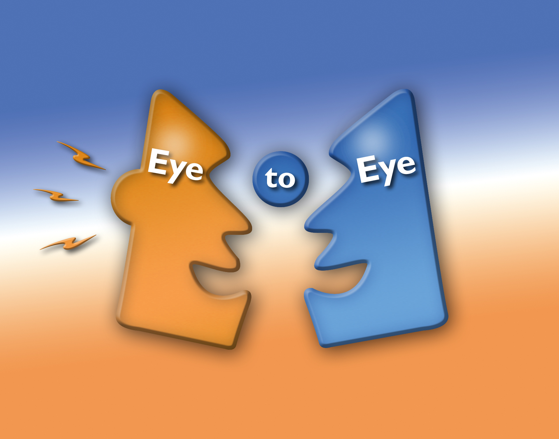
Eye to Eye Young People’s Counselling Service
Beddau CEC, Bryncelynnog School
Pencoedcae Road
Beddau,
Pontypridd
RCT,
CF38 2AE
01443 202940
www.eyetoeye.wales

Important Information

Eye to Eye Young Peoples counselling service is planning to continue to deliver counselling to young people in RCT during the Covid 19 outbreak.

All our counsellors will be offering online counselling through face to face and text chat to young people aged 11 to 25 years. These young people will need access to the internet and a quiet confidential place to talk.

Referrals can be made between 11am and 3pm on numbers

01443 202940
07541783767

You can also refer at
info@eyetoeye.wales

Please ensure when making a referral that besides the usual information you also have the following;
- Young person’s email address and contact telephone number
- Parent’s name and contact number

Thank you

Alison Theaker
Head of Service
Eye to Eye Young Peoples Counselling Service

