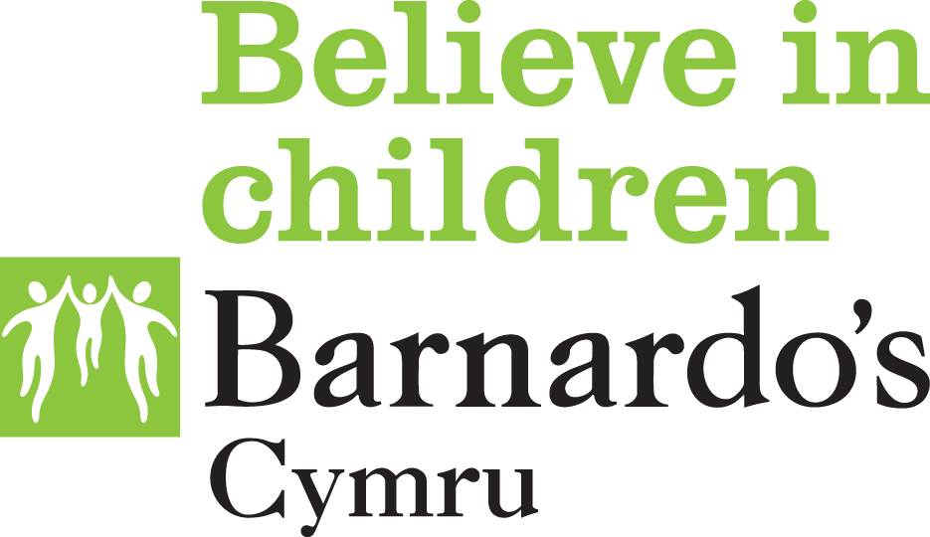

SERAF Risk Assessment: Scoring Guidance

Vulnerabilities
This section of the risk assessment form includes factors that we know may render children and young people vulnerable to being targeted for child sexual exploitation.
Each vulnerability carries a score of 1.

Moderate risk indicators
This section of the risk assessment form includes indicators that are associated with risk of or that may indicate abuse through sexual exploitation.
These should be ticked if they are currently present or have been present during the past 6 months. Each moderate risk indicator carries a score of 1.

Significant risk indicators
These risk indicators are very prevalent in cases where children and young people are at risk of or are being abused through sexual exploitation. In order to monitor any change in risk over time as a result of intervention or a change in circumstances is important to know whether the risk indicator is current (on date of referral or in past 6 months) or recent (between 6 and 12 months ago).
If the risk indicator is current or has occurred in the past 6 months this carries a score of 5 (right hand column).
Where the risk indicator was present between 6 and 12 months ago but has not been present in the past 6 months this carries a score of 1 (left hand column).
If a significant risk factor has been present during the past 6 months and was present between 6 and 12 months ago both column should be ticked generating a score of 6 in relation to that significant risk indicator.
Once the form is completed a total score can be worked out.
Each score generates a category of risk.
Each category of risk has an associated action (see SERAF Categories of Risk Framework).

Score
0-5 = Category 1: (Not at risk)
6-10= Category 2: (Mild risk)
11-15= Category 3: (Moderate risk)
16 + = Category 4: (Significant risk)

- It is essential that all available information is recorded on the SERAF Risk Assessment Form.
- A SERAF Risk Assessment should be carried out at regular intervals to record any increase or reduction in risk and should inform appropriate intervention.
- A SERAF Risk Assessment should always be carried out following a change in circumstances (e.g. change in placement) as this can have a significant impact on risk.
- If any of the significant risk indicators are identified but the child is categorised as ‘not at risk’ or as at ‘mild risk’ a discussion with the team manager and any other professionals or carers involved in the child’s life should take place. This is necessary to ensure that all the information relevant to the case has been included in the risk assessment.
- Cases involving children under the age of 13 who have one or more of the significant risk indicators present should score an additional 5 to be added to the total assessment score to reflect the additional vulnerability of their age.

