For Urgent Child Protection concerns, ring Police on 999

Section 1

Section 1 should be completed in full. Where there are safeguarding concerns, this section of the form will be shared with Children’s Services without consent, in line with our statutory obligations.

Please indicate below If this is a concern relating to a:
Child |  |  |  |  |  | Professional |  |  |  |  |  |  |  |  | Both Child and Professional
Please provide details:

1. Child/Young Person’s Details (add any additional names on separate sheet)
Last Name | First Name |  |  |  | Age |  |  |  | DOB/EDD |  |  |  |  | Male /Female /  Transgender /  Other (please state) / Prefer not to say |  |  |  | Ethnicity (see guide) |  |  |  | 1st Language
Address(es) |  |  |  |  |  |  |  |  |  |  |  |  |  |  |  |  | Post code(s)
Tel/Mobile |  |  |  |  |  |  |  |  | Email
Tel/Mobile |  |  |  |  |  |  |  |  | Email
Tel/Mobile |  |  |  |  |  |  |  |  | Email
2. Reason for Referral
Outline the safeguarding / Child Protection or support needs concerns you have for this/these child/ren
Do you have other concerns for this/these child/ren? And/or for their carers parenting capabilities?
What are your concerns based on?
What are the risks?
(What information have you gathered about the child/ren /family?)
What support has already been offered by your agency and/or other agencies and what were the outcomes in terms of helping the family?
Why are you referring for further support for the child/ren at this point?
3. Child(ren)/Young Person(s)’ Principal Carers
Carer Last Name | Carer First Name |  |  |  | Relationship to child |  |  |  | Parental Responsibility?  Y / N / Not known |  |  |  |  |  | Male /Female /  Transgender /  Other (please state) / Prefer not to say |  |  |  | DOB/Age |  |  | Ethnicity (see guidance)
Give carer address(es) here if different from the child(ren)’s |  |  |  |  |  |  |  |  |  |  |  |  |  | Post Code(s)
Tel/Mobile |  |  |  |  |  |  |  |  |  |  | Email
Tel/Mobile |  |  |  |  |  |  |  |  |  |  | Email
Is the carer aware of this referral?
4. Other Household Members or Significant People in the Child/Young Person’s Life (where known)
Last Name |  |  | First Name |  |  | Age |  |  |  | DOB/EDD |  |  |  |  | Male /Female /  Transgender /  Other (please state) / Prefer not to say |  |  | Ethnicity (see guidance) |  |  | Relationship to child
Address |  |  |  |  |  |  |  |  |  |  |  |  |  |  |  |  |  | Post Code
Address |  |  |  |  |  |  |  |  |  |  |  |  |  |  |  |  |  | Post Code
Tel/Mobile |  |  |  |  |  |  |  |  |  |  |  |  | Email
5. Details of Person(s) causing Concern (where known)
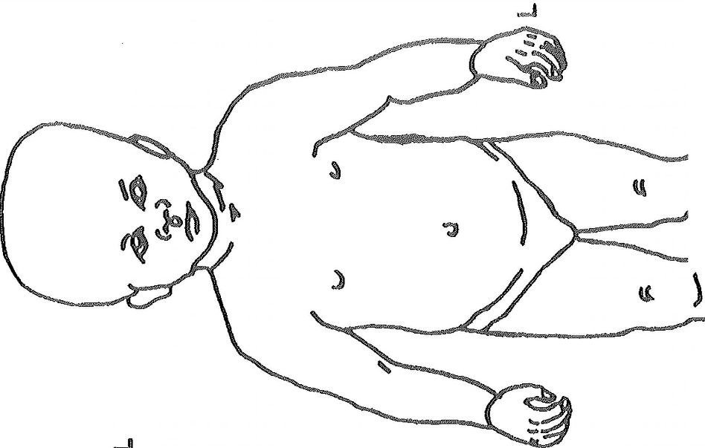  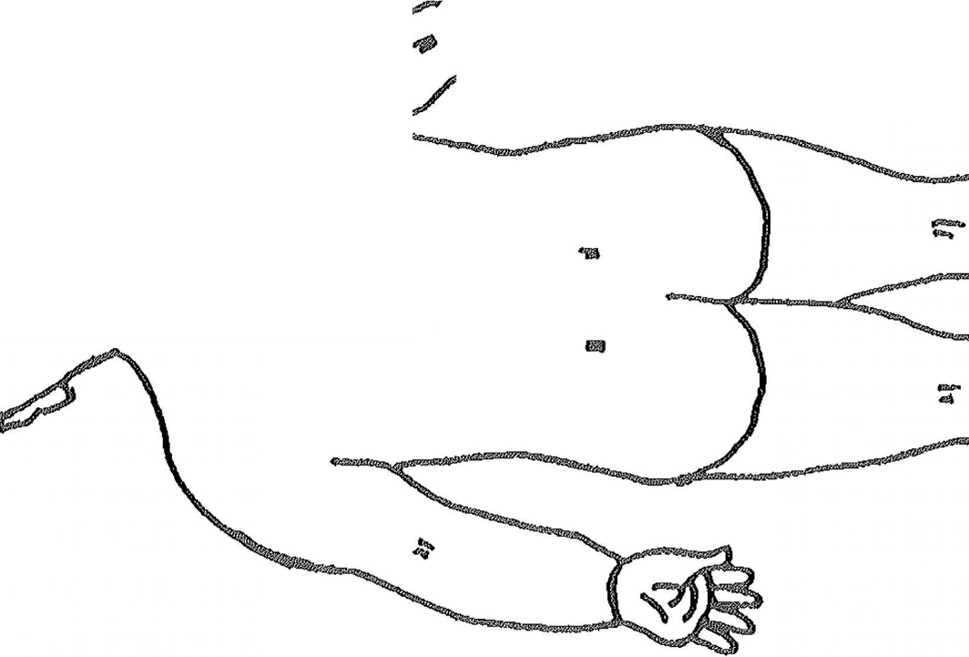  Last Name | First Name |  |  |  | Age |  |  |  | DOB |  |  |  |  | Male /Female /  Transgender /  Other (please state) / Prefer not to say |  |  |  | Ethnicity (see guidance) |  |  | Relationship to child
Address
Address
Tel/Mobile |  |  |  |  |  |  |  |  |  |  |  |  | Email
Is person of concern aware of this referral?
Are there any communication/interpreting needs for the child and/or family?
Does the child and/or family have a disability or specific health needs? Please give full details
Are there any risks to the person visiting the home?

6. Details of Practitioner Making the Referral
Name: |  |  |  |  |  |  |  | Job Title |  |  |  |  |  |  |  | Agency/Team:
Date of Referral |  |  |  |  |  |  |  | Time |  |  |  |  |  |  |  | Telephone

7. Other Professionals currently involved (to include GP, health visitor and school details)
First Name | Family Name | Job Title | Team/Agency |  |  |  | Address |  |  |  | Telephone/  Mobile
8. Details of previous statutory, specialist or targeted involvement. Provide full details
Children’s Social Services |  |  |  |  | No | □ |  | Yes | □ |  | Not Known
Child and Adolescent Mental Health Service (CAMHS) |  |  |  |  |  | □ |  |  | □
Special Education Needs or Disability |  |  |  |  |  | □ |  |  | □
Specialist Health |  |  |  |  |  | □ |  |  | □
Adult Services (Health/Substance Misuse/Disability/Social Services/ Domestic Abuse) |  |  |  |  |  | □ |  |  | □
Youth Offending Service |  |  |  |  |  | □ |  |  | □
Police / Probation |  |  |  |  |  | □ |  |  | □
Other |  |  |  |  |  | □ |  |  | □
9. Details of Previous Assessments (Resilient Families, MIA) |  |  |  | No |  |  |  |  | □ | Yes |  | □
 |  |  |  | If Yes please state:

Section 2 - Consent

This section MUST be completed where there are NO safeguarding concerns. You will need to obtain Parent / Carer consent to being referred to Children’s Services for additional care and support services.

10. Consent/Awareness:
Have Parents/Carers given consent for this referral? |  | No | □ | Yes | □ | State where consent is documented:
Has the child or young person given consent for this referral? |  | No | □ | Yes | □ | State where consent is documented:
Has the parent/carer consented to a referral to supportive services i.e. Resilient Families (RCT)  Multiple Intervention Assistance – Merthyr)  (Please see C1 guidance for further information) |  | No | □ | Yes | □ | A referral cannot be made without consent.  State where consent is documented:
If parent/carer has not given consent or has not been made aware of this referral, please provide reason why. |  |  |  |  |  | Date:
Email this form securely
Secure email for Rhondda Cynon Taff: IAATeam@rctcbc.gov.uk
Secure email address for Merthyr: childrens.mash@merthyr.gov.uk
MASH telephone number for professionals use: 01443 743730
Out of hours: 01443 743665 Email: SocialWorkEmergencyDutyTeam@rctcbc.gcsx.gov.uk

