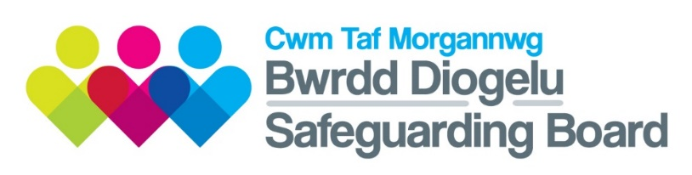

**CHILD PROTECTION CONFERENCE COMPLAINTS**

1. **Who can make a complaint?**

**2) What can a person complain about?**

**3) Exclusions**

The procedure will not address complaints that include:

* Complaints about a single agency's processes.
* Services delivered by agencies to the child or adult at risk.
* Complaints about an individual's practice or conduct of an officer

These complaints should be made via the relevant agencies’ complaints process.

Anyone directly involved in the child protection process can make a complaint which will be considered by the Safeguarding Board. If the complaint is deemed not appropriate then an explanation will be made in writing outlining the reasons for this decision.

To access the full guidance document visit the [CTMSB website.](http://cwmtafmorgannwgsafeguardingboard.co.uk/En/Professionals/JointPoliciesandProcedures/J3CTMSBComplaintsProcedureapprovedDecember2019.docx)

Parents, caregivers and children/young people who are involved in the conference process may wish to raise a complaint in respect of one or more of the following aspects of the functioning of the child protection conference:

* The process of the conference in terms of adherence to procedures;
* The registration decision, including the category;
* The decision not to register or to de-register.

1. **Decision of the Panel**

The Panel cannot change the decision of the conference.

If any part of the complaint is upheld and the Panel is of the view that this has affected the decision of the conference, it can recommend that the conference is reconvened with a different person chairing.

The original conference decision will remain in place until the reconvened conference has taken place.

If any part of the complaint is upheld but it has not affected the decision of the conference, the Panel may make recommendations for future learning.

In some cases complainants may raise concerns about individual agencies during the course of the Panel meeting, should this happen and the information provided raises concerns about the quality of practice within that agency, the Chair of the Panel will discuss these with the designated senior manager of the agency concerned immediately following the Panel meeting.

**4) Stage 1 – Resolution by Conference Chair**

A complaint should be made in writing, by telephone or in person to the Conference Chair who will attempt to resolve it within 10 working days.

If the complaint is not resolved, the local authority Manager for Child Protection will provide the complainant with an opportunity to proceed to the next stage. This [form](http://cwmtafmorgannwgsafeguardingboard.co.uk/En/Professionals/FormsandTemplates/CtmsbComplaintFormDecember2019.docx) should be used.

[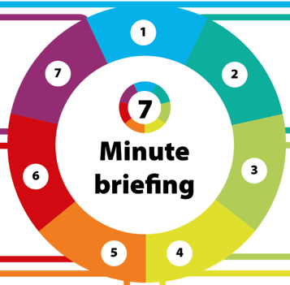](https://www.google.co.uk/url?sa=i&rct=j&q=&esrc=s&source=images&cd=&ved=2ahUKEwjYyujwlqvmAhVkDWMBHcuRCYQQjRx6BAgBEAQ&url=https%3A%2F%2Fwww.safeguardingwarwickshire.co.uk%2F&psig=AOvVaw3OmBWPsppeiWIV9axgFawJ&ust=1576070656373011)

*Adapted from 7 minute briefing created by Hywel Dda University Health Board*

An independent Inter-agency Complaints Panel will be convened, consisting of a minimum of three representatives from the Board.

The complainant will be advised of the meeting and be provided with an opportunity to attend to present their complaint. They will be entitled to be accompanied by a person of their choice.

The Panel has 25 working days from the date that the complaint was signed to inform the complainant of their findings.

**6) Stage 2 – Inter-agency Complaints Panel**

**5) Complaints about the Conference Chair**

A complaint should be made in writing, by telephone or in person to the local authority Manager for Child Protection, who will attempt to resolve the complaint within 10 working days.

If the matter is not resolved then the local authority complaints procedure should be initiated.

**What next?**